Kiana Rezaee  
Dr. Pippin Barr

Cart 253  
September 15, 2024

**Venus Turning: Learning Computational Creativity**

What is my relationship with programming? In early fall last year, my answer to this question would be simpler: “I have close to none”. But after a year in the Computation Arts program, I have realized that even prior to learning anything about programming, technically and theoretically, I was already in the midst of a lifelong relationship with it. Programming, like many fields, is the joint effort of humans in the past to create quotidian modern-day tools. While I sit here writing on word processing technology, hundreds of years ago people like Henry Mill dreamt of typing as I do (Hubert 1888, p.2). This historic continuum within itself is a beautiful and complex collective programming story that I take part of day to day.

As a creative tool, programming simply perplexes me. As I watched the “Mother of All Demos” and subsequently read the Augmentation Research Center’s description of their goals (Engelbart 1968), I felt extremely moved and found the designing process to be beyond creative. I believe creative aspects of programming are now considered tied to the audiovisual impact it can produce. This is possibly due to how normalized our other functional experiences with it are.

I found this to be true in my short practical experience with programming. Over the span of 2023-2024, I built two websites for different courses. In one I took the opportunity to create a website which introduces the raccoon to the viewer (Rezaee, 2023), featuring mostly my own visual artistic work inspired by the combination of the early internet and painterly impressionist styles. I found it easier to begin thinking creatively if the project included things I liked. I look back at the raccoon project in a fonder manner. My second site is an ongoing endeavor, it is a site about immigration (Rezaee 2024). While I am passionate about the subject, I did not enjoy the experience as it was draining and mechanical. I felt underappreciated and disconnected in my technical role and due to personal difficulties during the course. Despite this, I want to finish it as it is *my* creative project, the notes I collected to archive on it sit at my desk waiting for me.

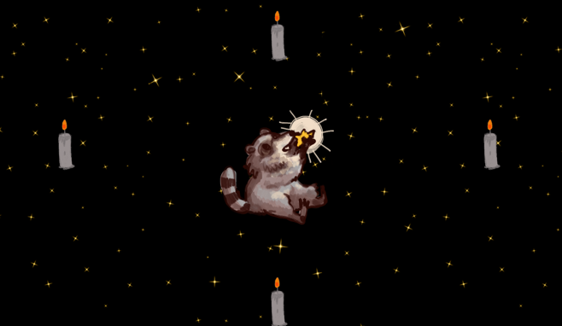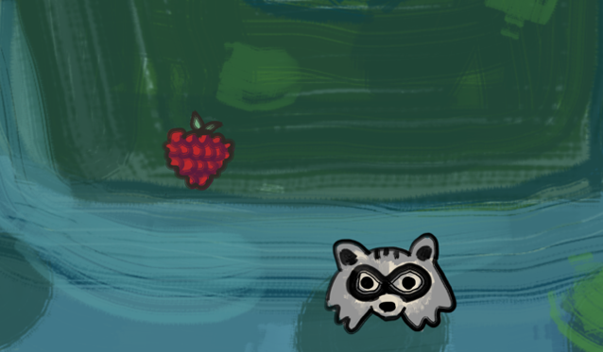

Screenshots from my raccoon game site (taken 2024)

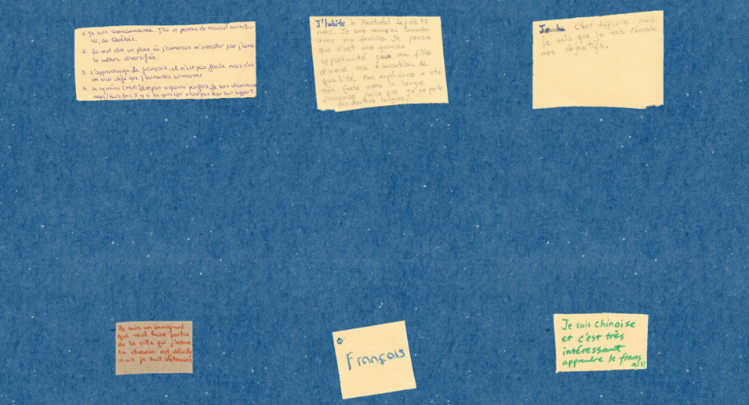

Screenshots of notes from my immigration website (taken 2024)

It is hard to realize that emotions that go into coding are just as complex as any other artistic tool as it is easier to commodify since it’s a new form of media. Perhaps, slowly even audiovisual appreciation of programming and computation will diminish. Change is fast occurring and this is more evident as the age of computational creativity is close to its peak; AI passed both the older benchmark of the Turing test (Turing 1969) and the newer requirements outlined by the Computational Creativity Conference Steering Committee (Jordanuos 2014).

The highest level of inspiration to me is those who dreamed of today, without much prior inspiration. Having the ability to think of Venus turning. The Ada Lovelaces and Maria Mitchells of the world who embodied technology. Functionality and innovation are an end goal for me as I think it adds a great deal to the collective pursuits. However, I am currently less interested in functional coding and more inspired by coding for interactive and experimental visual effects. My inspirations for this include:

* Hadi Jamali’s Serendipity

Jamali’s usage of traditional elements, HCI (Human Computer Interaction), and immersion was beautiful to witness in real life. Evan Montpellier had to program the work to respond to movement, creating the possibility for the full immersive effect and allowing the viewer to become one with the images and music (Jamali 2023). Movement and gestural based works can sometimes feel underwhelming and repetitive, Montpellier’s role in this is to bear the weight of breaking the fourth wall. However, the good mesh of culturally sound narration and fluid animation and development style allowed it to remain unique.

* Before Your Eyes (Goodbyeworld 2021)

The concept behind this game, detecting your blinking as you play, inspired me to think of the future of games and art in a deeper manner. Programming innovatively and accounting for variability made the liminal feelings associated with gameplay in this possible (Maher 2021). It is creative not only in its usage of new technology, but its combination of psychological and narrative tools. Programmers in this work are essentially ushering in a new manner of connecting to the computer with your body.

* Shirin Neshat’s Fury (Neshat 2022)

I saw this in person and was extremely touched. This project uses two screens and a VR headset, for both of these sections, programmer Peter Fisher is essential to the work as he must ensure the smooth running and visually immersivity of the project. Fisher stated that he works closely with contemporary artists to ensure their visions come to life (Kentbye 2023). With his abilities as a creative programmer, Fisher creates the ability for the artist and viewers to meet in a third space wherein we are almost present in her mind.

While I wait to find the functional gap I would like to fill, I imagine smaller projects that contribute to a collective, like finishing my immigration website. In a bigger sense, I would also like to create more localized archives for my home country, Iran. In my limited programming imagination, I see a software with a map where users can collaboratively upload neighborhood photos. Unlike many other countries, local history is not well preserved and of course google street view is banned, there is no comparative archival method for people to feel nostalgia about.

Within this course visual projects, I need to learn creativity in programming. I want to create interactive artworks which implement traditional elements to preserve them in the digital realm and question our increasingly non-tangible lives. Diverse cultural elements and oral tradition are always a great addition to contemporary art which I like to do. Hopefully this goal is achievable.

**Sources**

Engelbart, Douglas C., and William K. English. 1968. “A Research Center for Augmenting Human Intellect.” In *Proceedings of the December 9-11, 1968, Fall Joint Computer Conference, Part I*, 395-410.

Goodbyeworld Games. 2021. “Before Your Eyes.” *Skybound Games.* Accessed September 15, 2024. <https://www.beforeyoureyesgame.com/>.

Hubert, Philip Gengembre. 1888. “The Typewriter; Its Growth and Uses.” *The North American Review*. Jamali, Hadi. 2023. “Serendipity.” Accessed September 15, 2024. https://hadijamali.com/serendipity/ and <https://evanmontpellier.net/serendipity.html>.

Jordanous, Anna. 2014. “What Is Computational Creativity?” *The Creativity Post*. Accessed September 15, 2024. <https://www.creativitypost.com/science/what_is_computational_creativity>.

Kentbye. 2023. “The Fury Combines Two-Channel Video Installation with 360 Video to Explore Memories of Sexual Assault.” *Voices of VR*. Accessed September 15, 2024. <https://voicesofvr.com/1238-the-fury-combines-two-channel-video-installation-with-360-video-to-explore-memories-of-sexual-assault/>.

Maher, Cian. 2021. “Before Your Eyes Interview - A Game Where Your Eyes Are the Controller.” *The Gamer*. Accessed September 15, 2024. <https://www.thegamer.com/before-your-eyes-interview-blink/>.

Neshat, Shirin. 2022. “The Fury.” *Centre Phi*. Accessed September 15, 2024. <https://phi.ca/en/events/the-fury/>.

Rezaee, Kiana. 2024. “People Not Numbers.” *People Not Numbers*. Accessed September 15, 2024. <https://www.peoplenotnumbers.art/>.

Rezaee, Kiana. 2023. “Why a Raccoon?” *Hybrid Concordia*. Accessed September 15, 2024. <https://hybrid.concordia.ca/K_REZAEE/final_proj/startpage.html/>.

Turing, A. 1969. “Intelligent Machinery.” In *Machine Intelligence 5*, edited by D. M. B. Meltzer, 3-23. Edinburgh University Press. Originally published as a National Physics Laboratory Report, 1948.